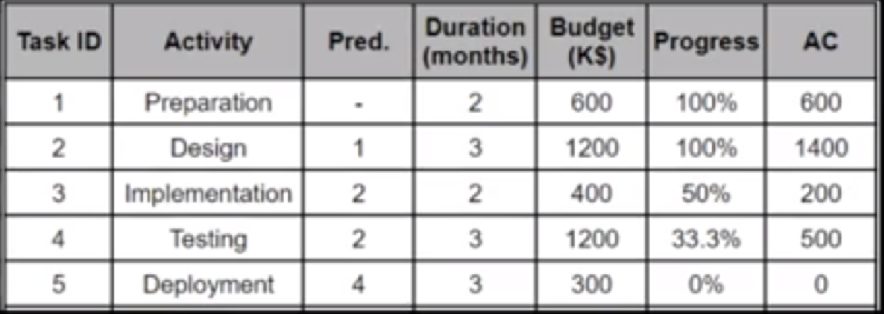

* How Much, Is It Over/ Under Budget?

As $600,000 more than the expected budget, It’s over budget

* How Many Days, Is It Ahead/Behind the Schedule?

As more than 5 months late, it’s Behind the Schedule

* By The End Of the Project, By How Much Will It Be Over/ Under Budget?

$600,000 more than the expected budget

 CV = EV - AC

* ETC = (total budget - EV) / CPI.
* EAC = AC + ETC.
* SV = EV - PV
* CV = EV- AC
* PV = scheduled progress \* budget.
* SPI = EV/PV
* AC = 600 +1200+400+1200+300 = $3700
* EV = 600+1400+ 200\*50% + 500\*33.3 + 300\*0%= $2266.5
* CPI= EV/AC= 2266.5/3700 = 0.613
* ETC = (3700 – 2266.5) / 0.631 = $2271.8
* EAC= 3700 + 2271.8 = $5971.8
* CV = 2266.5 - 3700 = -1433.5